Name: Daniella Ayilara
Course/Cohort: Data Analytics - July
Date: September 2026

Superstore Sales and Profit Analysis Report

This report analyzes Superstore’s sales and profit performance using Power BI and Tableau dashboards. The purpose of the analysis is to identify underperforming product areas, examine sales and profit trends over time, investigate factors affecting profitability, and compare regional performance to understand possible causes of profit decline.

1. Analysis of Underperforming Categories and Sub-Categories

The Sub-Category Profit analysis shows that profitability differs significantly across product lines. While several sub-categories contribute positively to overall profit, some areas perform poorly.

The analysis identifies Bookcases as an underperforming sub-category, showing negative profit compared with other product areas. Other low-performing sub-categories should also be reviewed to understand whether pricing, operational costs, or customer demand are affecting profitability.

In contrast, sub-categories such as Copiers, Phones, and Accessories show stronger profit performance and contribute positively to business returns.

Recommendation:
Management should investigate low-profit products and consider improving pricing strategies, reducing costs, or adjusting inventory decisions.

2. Sales and Profit Trends Over Time

The monthly sales and profit trend analysis shows changes in business performance throughout the year.

The dashboard indicates that sales generally increase towards the later months, with stronger performance during the final quarter. However, increases in sales do not always result in equal increases in profit, suggesting that other factors such as discounts and product profitability influence financial outcomes.

Key Insight:

The company should focus on generating profitable sales rather than only increasing sales volume.

3. Factors Affecting Profitability

The Discount and Profit analysis highlights a relationship between discount levels and profit performance.

The scatter plot shows that higher discounts can sometimes result in reduced or negative profits. Although discounts may help increase sales, excessive discounting can reduce profit margins and affect overall profitability.

Possible factors contributing to profit decline include:

- High discount rates reducing profit margins
- Low-performing product sub-categories
- Products generating sales but providing limited profit
- Differences in regional performance

Recommendation:
The company should review discount strategies to ensure promotions increase revenue without significantly reducing profit.

4. Regional Performance Comparison

The regional analysis compares the performance of the four regions: West, East, Central, and South.

The dashboards show differences in sales contribution across regions. Although some regions generate higher sales, sales volume alone does not determine profitability. Profit performance should also be considered when evaluating each region.

Since the business has identified declining profit in the South, Central, and East regions, these areas require further investigation to determine whether the decline is caused by product mix, discount levels, or changes in customer purchasing behaviour.

Recommendation:
Management should conduct a deeper regional analysis focusing on profit trends over time to identify specific causes and solutions.

5. Recommendations

Based on the dashboard analysis, the following actions are recommended:

1. Review underperforming sub-categories and identify reasons for low profitability.

2. Reduce excessive discounts that negatively affect profit margins.

3. Promote products with stronger profit performance.

4. Monitor regional profitability, especially in the South, Central, and East regions.

5. Balance sales growth with profitability by focusing on high-value business opportunities.

6. Conclusion

The Power BI and Tableau dashboards provide valuable insights into Superstore’s sales and profit performance. The analysis shows that profitability is influenced by product performance, discount strategies, sales trends, and regional differences.

By improving discount management, reviewing underperforming products, and developing targeted regional strategies, Superstore can address profitability challenges and improve overall business performance.

Appendix: Power BI Dashboard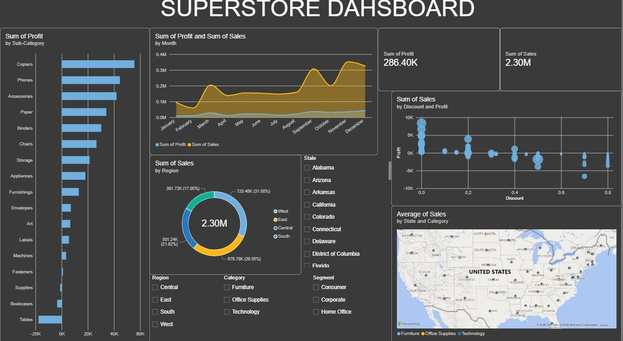

Appendix: Tableau Dashboard